**MTF Information Portal**

**(Discern Reporting Portal)**

Log into Discern Reporting Portal

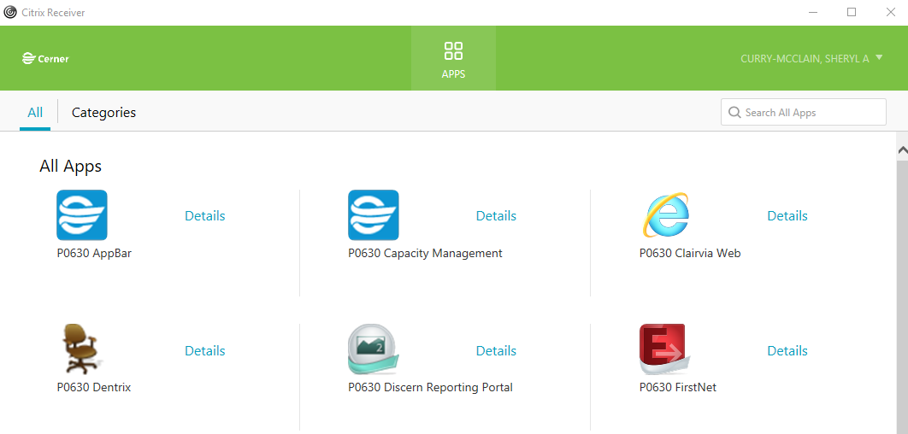

Type MTF in search field. Choose MTF Information Portal and Run Report.

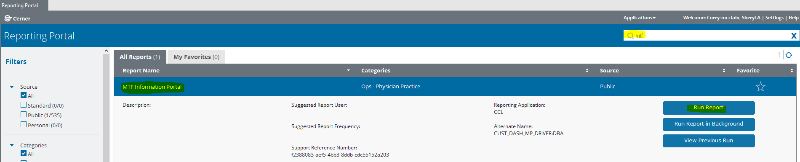

At the Discern Prompt, choose how you want the report to output (MINE is a view function), and click on Execute.

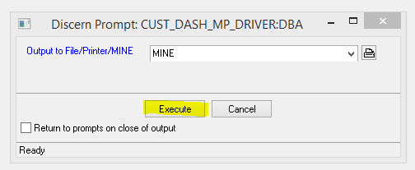

Choose date parameters and enter DMIS (location code), click on drop down arrow and select desired location (you can select all locations associated with the location code, a single location or several selected locations). Click on Build Report.

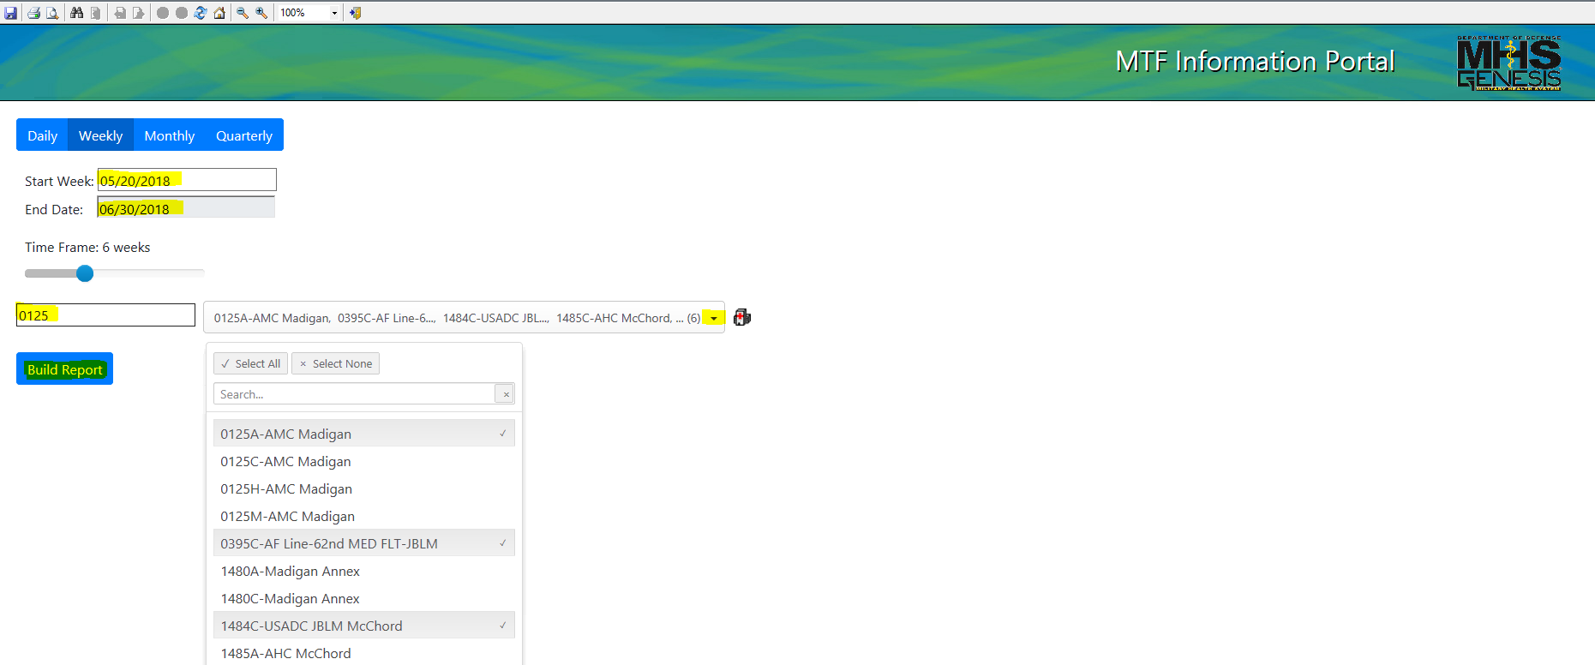

There is a 24 hour lag time on the reports. You can get real time reports (if available for specific report) by clicking on the paper icon.

The  icon provides parameters for the report.

The  icon shows a graph of the report.